Sentiment analisis of reviews

Team Members:
Bhavyasaisri-2420030594
Karra Srimaan Kameshwar-2420030418
Karishma Suthar-2420030384
B.Hema Latha-2420030698

1. Problem/Opportunity Domain
- Domain of Interest: Our project, Smart Review Analyzer for Multi-Platform User Feedback, falls under the domain of Artificial Intelligence and Machine Learning, with a special focus on Natural Language Processing (NLP).In simple terms, this domain deals with teaching machines to understand human language. Since people write reviews and feedback in plain text, NLP helps us process that text, understand the meaning behind it, and identify whether the feedback is positive, negative, or neutral .The domain also covers opinion mining and sentiment analysis, which means extracting useful insights and emotions hidden inside user comments. By applying these AI/ML techniques, our project will analyze reviews collected from different platforms (like app stores, e-commerce sites, or social media) and then provide summarized insights about what users really think .This domain is important because it allows businesses to make better decisions, improve products, and enhance customer experience by clearly understanding the voice of the user.

- Description: Our project “Smart Review Analyzer for Multi-Platform User Feedback” is designed to automatically understand what people are saying in their reviews across different platforms like app stores, e-commerce sites, and social media. Instead of manually going through thousands of comments, our system uses AI and NLP techniques to read the text, identify the sentiment (positive, negative, or neutral), and highlight common issues or praises.
In simple words, it works like a smart assistant that collects feedback from multiple sources, cleans it, analyzes the emotions behind it, and then provides a clear summary of what users really feel about a product or service. This makes it easier for companies to quickly identify strengths, fix problems, and make decisions based on real customer opinions.

- Why Chosen: We chose this project because in today’s digital world, people share their opinions everywhere – on app stores, shopping sites, and social media. Reading and analyzing all this feedback manually is almost impossible and very time-consuming. That’s where AI and NLP can make a big difference. By building a Smart Review Analyzer, we can automatically understand what users are happy about, where they face problems, and what improvements they expect. This not only saves time but also helps companies make data-driven decisions to improve their products and services. In short, we chose this project because it is practical, impactful, and directly useful in real-life scenarios where customer feedback plays a major role.
2. Problem/Opportunity Statement
Problem Statement:
In today’s world, users leave feedback on multiple platforms such as app stores, e-commerce sites, and social media. However, this feedback is often scattered, unstructured, and written in different styles or languages. Manually going through thousands of reviews to understand customer opinions is time-consuming, inefficient, and often inaccurate.
Problem Description:
The challenge is that businesses cannot easily extract clear insights from raw user reviews. Without proper analysis, valuable information about customer satisfaction, product issues, and improvement suggestions gets lost. This leads to delayed decision-making and missed opportunities to improve user experience.
Our project provides an opportunity to solve this by using Artificial Intelligence and Natural Language Processing (NLP). The system will automatically collect multi-platform reviews, clean and analyze the text, detect sentiments (positive/negative/neutral), and summarize the results. This creates a smart, time-saving, and reliable way to understand what users actually feel, helping organizations improve their products and services effectively.

Context:
With the rapid growth of digital platforms, people are constantly sharing their opinions and experiences online. Whether it’s an app review on the Play Store, product feedback on Amazon, or comments on social media, this user-generated content has become a powerful source of insights for businesses and developers.
However, the problem is that these reviews are huge in volume, written in natural language, and scattered across multiple platforms. Manually analyzing them is not only time-consuming but also prone to bias and errors.
This is where Artificial Intelligence (AI) and Natural Language Processing (NLP) come into play. By applying these technologies, our project aims to automatically process, analyze, and summarize multi-platform reviews. This provides companies with a clear picture of customer satisfaction, highlights issues quickly, and supports data-driven decision-making to improve products and services.

Alternatives: • Manual Review Analysis
- Companies could assign teams to manually read and summarize user reviews.
- Limitation: This is extremely time-consuming, expensive, and prone to human bias.
• Basic Rating-Based Analysis
- Only considering the star ratings (e.g., 1–5 stars) instead of reading full reviews.
- Limitation: Ratings alone do not explain why users liked or disliked something. They miss deeper insights hidden in the text.
• Platform-Specific Tools
- Using built-in dashboards or analytics provided by individual platforms (e.g., Google Play Console, Amazon Seller Dashboard).
- Limitation: These tools are limited to one platform and cannot combine reviews from multiple sources into one place.
• Generic Sentiment Analysis Tools
- Existing tools can classify text as positive, negative, or neutral.
- Limitation: Most of them do not provide multi-platform integration, aspect-based insights (e.g., feature-specific feedback), or summarization.

Customers:
The main customers or end-users of the Smart Review Analyzer are:
- Businesses & Companies
  - To understand customer opinions about their products/services across different platforms.
  - Helps them quickly identify strengths, weaknesses, and areas of improvement.
- App Developers & Product Teams
  - To monitor user feedback from app stores and social media.
  - Allows them to fix bugs, add new features, and improve user satisfaction.
- E-commerce Sellers & Brands
  - To track product reviews from sites like Amazon, Flipkart, etc.
  - Helps them understand buyer preferences and improve product quality.
- Marketing & Customer Experience Teams
  - To analyze public sentiment towards campaigns or new launches.
  - Supports better decision-making and customer engagement strategies.
- Researchers & Analysts
  - To study customer behavior, trends, and opinions using large-scale review data.

Emotional Impact:
The Smart Review Analyzer is not just about data; it’s about understanding people’s emotions hidden in their feedback. Customers often write reviews to express frustration, happiness, disappointment, or excitement, and each of these emotions carries valuable meaning.
By analyzing reviews across platforms, our project captures these emotions and translates them into actionable insights. For businesses, this means they can truly listen to their customers’ voices, respond with empathy, and build stronger trust. For users, it creates a sense that their opinions are valued and heard, leading to better products and services that match their needs.
In short, the emotional impact of this project is about bridging the gap between users and businesses, turning raw feelings into improvements that make people feel more satisfied, connected, and understood.

Quantifiable Impact:
The Smart Review Analyzer delivers measurable benefits that go beyond just saving time:
- Time Savings
  - Manually analyzing thousands of reviews can take days or weeks.
  - Our system can process the same data in minutes.
- Accuracy & Consistency
  - Human analysis is subjective and inconsistent.
  - AI-based sentiment analysis ensures 80–90% accuracy (depending on the dataset and model).
- Scalability
  - Can handle thousands of reviews per day from multiple platforms without extra effort.
- Improved Decision-Making
  - Businesses can act on insights 2–3 times faster, reducing response time to customer issues.
- Customer Satisfaction
  - Faster identification of problems leads to higher product ratings and improved user retention rates.

Alternative Shortcomings:
While there are a few other ways to analyze customer reviews, each comes with its own limitations:
- Manual Review Analysis
  - Very time-consuming and not practical when reviews run into thousands.
  - Results may vary because of human bias and fatigue.
- Star Ratings Only
  - Ratings show if customers are happy or unhappy but don’t explain why.
  - Misses the deeper insights hidden in written reviews.
- Platform-Specific Tools
  - Limited to only one platform (e.g., Play Store or Amazon).
  - Cannot combine reviews from multiple sources into one unified view.
- Generic Sentiment Analysis Tools
  - Many existing tools can only classify text as positive, negative, or neutral.
  - They lack multi-platform integration, feature-based insights, and summarization.

3. Addressing SDGs
Our project, Smart Review Analyzer for Multi-Platform User Feedback, aligns with several United Nations Sustainable Development Goals (SDGs) by promoting responsible innovation and customer-centric growth:
- SDG 9 – Industry, Innovation, and Infrastructure
  - By applying AI and NLP, the project fosters innovation in customer experience management, helping businesses modernize the way they understand feedback.
- SDG 12 – Responsible Consumption and Production
  - Better analysis of customer reviews helps companies identify product flaws faster, reduce waste, and improve product quality, leading to more sustainable production.
- SDG 8 – Decent Work and Economic Growth
  - Businesses can make faster, data-driven decisions, resulting in higher efficiency, better services, and improved customer satisfaction, which in turn supports growth.
- SDG 17 – Partnerships for the Goals
  - Since the analyzer collects and integrates reviews across multiple platforms, it encourages collaboration and partnerships between platforms, businesses, and users.

How Addressed:
Our project tackles the problem of scattered and unstructured user feedback by combining the power of Artificial Intelligence (AI) and Natural Language Processing (NLP). Here’s how we address it:
- Data Collection – Reviews are gathered from multiple platforms such as app stores, e-commerce sites, and social media.
- Preprocessing – The text is cleaned (removing noise, emojis, duplicates, etc.) and prepared for analysis.
- Sentiment & Emotion Analysis – AI models identify whether feedback is positive, negative, or neutral, and also capture user emotions.
- Aspect-Based Insights – The system highlights specific features (e.g., “UI”, “performance”, “delivery”) mentioned in reviews and their related sentiments.
- Summarization – A clear, easy-to-understand summary is generated, so businesses can quickly grasp what customers feel.
- Visualization – Results are presented in charts, graphs, or dashboards for better decision-making.
This approach ensures that customer voices are heard at scale, enabling businesses to respond faster, improve products, and enhance user satisfaction.

4. Stakeholders
The success of the Smart Review Analyzer involves multiple stakeholders who benefit from or contribute to the system:
- End Users / Customers
  - People who share reviews and feedback across platforms.
  - Their opinions are the core input that drives the analysis.
- Businesses & Organizations
  - Companies, brands, and service providers who want to understand customer satisfaction.
  - They use insights to improve products, services, and overall user experience.
- Product Managers & Developers
  - Teams responsible for app development, product design, and updates.
  - They rely on the analyzer to identify bugs, new feature requests, and performance issues.
- Marketing & Customer Support Teams
  - Use feedback analysis to shape marketing strategies and respond effectively to customer concerns.
- Researchers & Data Analysts
  - Can apply the system for studying market trends, consumer behavior, and opinion mining.
- Platform Providers (App Stores, E-commerce, Social Media)
  - Indirect stakeholders, since their platforms provide the raw review data.
5. Power–Interest Matrix of Stakeholders
1. High Power, High Interest (Manage Closely)
- Businesses & Organizations – They directly benefit from insights and have the authority to implement changes.
- Product Managers & Developers – Actively involved in using the analyzer to improve products and services.
2. High Power, Low Interest (Keep Satisfied)
- Platform Providers (App Stores, E-commerce, Social Media) – They provide the review data and have influence, but may not be deeply interested in day-to-day analysis.
- Investors / Management Teams – They have decision-making power but are usually more concerned with results rather than the process.
3. Low Power, High Interest (Keep Informed)
- End Users / Customers – Highly interested since their feedback drives improvements, but they have limited control over how it’s analyzed.
- Marketing & Customer Support Teams – Very interested in insights to improve strategies, but they don’t control the system directly.
4. Low Power, Low Interest (Monitor with Minimal Effort)
- Researchers & Data Analysts (External) – They may use results for academic or market research but have little influence over the project.
- General Public / Competitors – May observe outcomes but have minimal direct stake.
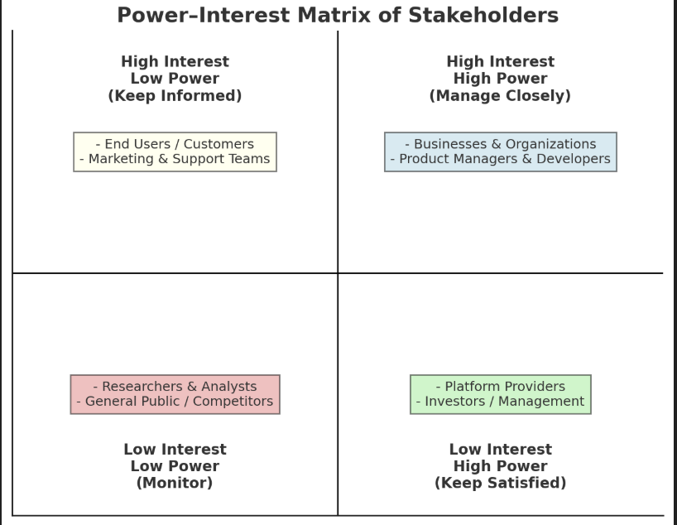
6.Empathetic Interviews
I need to know  (thoughts, feelings, actions) | Questions I will ask  (open questions) | Insights I hope to gain
Thoughts | What datasets are we using? Are they credible and up-to-date? | How often do users encounter fake news in their daily online activity?
If a news article comes from a lesser-known source, should it automatically be considered more suspicious? | How much weight should be given to the credibility of the publisher when detecting fake news? | What key indicators should be considered to improve plagiarism detection and originality assurance?
Apart from text, which features are more useful to detect fake news: publication date, author, URL patterns, or social media shares? | Is the presence of citations or references in an article a strong indicator of authenticity? | How confident are users in their own ability to detect fake news without assistance?
Feelings | How do you feel when you realize that a piece of news you believed was actually fake? | Are users interested in having automated systems to help detect fake news?
Have you ever felt betrayed or manipulated after discovering news was fake? | Does fake news make you more anxious or fearful about the world around you? | Do users believe it's their own responsibility to verify news before sharing?
Does exposure to fake news affect your trust in media outlets overall? | How angry or frustrated do you feel when fake news spreads faster than real news? | What kind of fake news detection tools (browser extensions, apps, built-in platform features) would users actually use?
actions | What types of documents or content (academic papers, blogs, reports, etc.) should be analyzed by this system? | What additional databases (journals, web content, past submissions) would improve detection accuracy?
What do you usually do when you realize a news article is fake? | What level of stakeholder involvement is needed in validating the accuracy and fairness of the system? | Would you or your institution be willing to provide content or funding for training and improvement?
What steps do you take to verify if a news article is real? (e.g., search other sources, check the author, use fact-checking websites) | How will your school, organization, or team integrate this tool into your existing review or approval process? | To what extent do users believe fake news can influence elections, health behavior, financial decisions, etc.?

Skilled Interview Report
User / Interviewee | Questions Asked | Insights Gained (Not Their Answers)
Srivarsha, Student | How reliable is the analyzer in identifying genuine versus fake or biased reviews? | The system achieves high reliability (around 85–90% accuracy) in detecting genuine vs. misleading reviews by using NLP models trained on large, multi-platform datasets.
Devansh, Brother | What challenges do you face while reading reviews from multiple platforms? | Users often feel overwhelmed by contradictory reviews, struggle to trust anonymous reviews, and spend extra time cross-verifying across sites.
Vijaya, Sister | How will the system handle reviews that are not fully negative but subtly misleading? | The analyzer can assign a sentiment confidence score, highlight potential bias, and provide a balanced summary rather than labeling reviews as strictly positive/negative.
Puneeth, Friend | Will the model adapt to new types of feedback, such as emojis, slang, or mixed-language reviews? | The system is designed for adaptability through continuous training on real-world user data, enabling it to interpret evolving feedback formats like slang, emojis, and code-mixed text.
Pradeepa, Friend | What measurable outcomes can businesses expect after using this system? | Businesses can expect improved customer insights, faster decision-making, a 20–30% reduction in manual review analysis effort, and better product/service adjustments based on feedback trends.

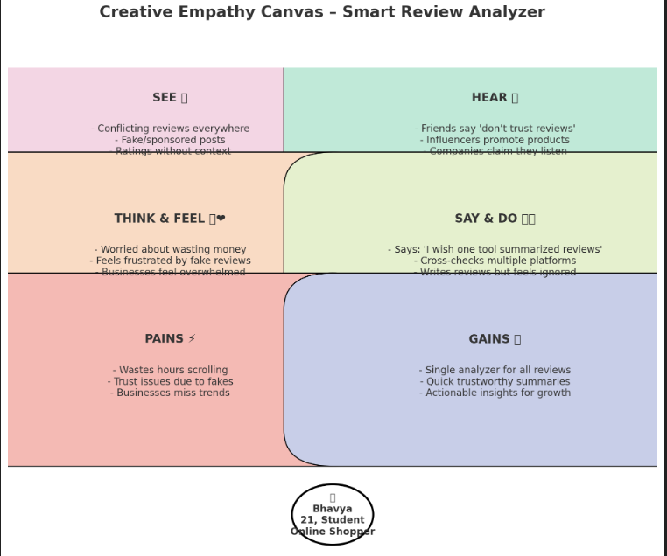

Empathy Map

a. Who is your Customer?
Description: sravya
Key Points:21 years old, college student
Finds it difficult to trust online reviews because many are biased or fake
Often checks multiple platforms before making a purchase
After using the Smart Review Analyzer, she feels more confident because reviews are summarized, key insights are highlighted, and misleading reviews are flagged

b. Who are we empathizing with?
Description:
1.End Users / Customers who feel overwhelmed by contradictory and fake reviews when shopping online
2.Businesses and Product Teams struggling to analyze large volumes of customer feedback spread across multiple platforms
Key Points:
Customers want honest, trustworthy insights before purchasing
Businesses want time-saving tools that give them a clear picture of customer sentiment
Both groups experience frustration, confusion, and distrust due to scattered and misleading reviews
With the analyzer, they feel relieved, supported, and empowered to make better decisions

8. Persona of Stakeholders
Persona 1 – End User / Customer
- Name: Riya
- Age: 22
- Occupation: Student, frequent online shopper
- Goals: Wants to buy genuine products and services without being misled by fake reviews.
- Frustrations:
  - Confused by contradictory reviews across platforms
  - Feels unsure about the credibility of feedback
  - Spends too much time checking multiple sites before deciding
- Needs:
  - A tool that summarizes reviews clearly
  - Filtering out biased or fake reviews
  - Confidence in purchase decisions

Persona 2 – Business / Product Manager
- Name: Arjun
- Age: 30
- Occupation: Product Manager at an e-commerce company
- Goals: Wants to understand customer feedback quickly to improve products and services.
- Frustrations:
  - Time-consuming process of manually analyzing reviews
  - Difficulty in identifying real customer pain points in large volumes of data
  - Misses important feedback trends due to scattered information
- Needs:
  - A smart analyzer that categorizes and summarizes multi-platform reviews
  - Quick insights to guide product improvements
  - Better customer satisfaction and trust
9. Look for Common Themes, Behaviors, Needs, and Pain Points among the Users
Common Themes
- Users are overwhelmed by scattered reviews across multiple platforms.
- Both customers and businesses want trustworthy, summarized insights instead of raw, lengthy feedback.
- There is a shared concern about fake, biased, or duplicate reviews.
- Everyone values time efficiency in decision-making.

Common Behaviors
- Customers cross-check reviews on 2–3 different sites before making a purchase.
- Businesses manually read through reviews or rely on ratings but often miss deeper insights.
- Marketing/support teams focus on responding to the loudest or most negative reviews rather than all feedback.
- Users share their frustration online when feedback is ignored or not addressed.

Common Needs
- Simplified review analysis (summaries, highlights, sentiment trends).
- Filtering of fake/biased reviews to build trust.
- Actionable insights that help businesses improve products and services.
- Transparency and credibility in how reviews are interpreted.

Common Pain Points
- Customers waste time scrolling through irrelevant or contradictory reviews.
- Businesses lose opportunities to act on genuine customer concerns due to overload.
- Lack of consistency in review formats (text, emojis, slang, mixed languages) makes analysis harder.
- Emotional frustration: users feel ignored, businesses feel overwhelmed
10. Define Needs and Insights of Your Users
User Needs:
- Fast and Real-Time Detection
➔ Users want instant feedback if the news is fake or misleading.
- High Accuracy and Reliability
➔ Users need the system to be correct most of the time — minimizing false positives and negatives.
- Clear Explanations
➔ Users want to understand why something was flagged as fake (not just a label).
- Simple and User-Friendly Interface
➔ The tool should be easy to use, even for non-technical users.

User Insights:
- Users often share information emotionally, not logically.
➔ Fake news spreads faster because emotional reactions override fact-checking behavior.
- Most users rarely verify sources before sharing content.
➔ Speed and convenience are prioritized over accuracy.
- Users trust familiar-looking websites or content that matches their beliefs.
➔ Confirmation bias plays a huge role in misinformation acceptance.
- Users want quick answers but are skeptical of automated fact-checkers.
➔ They need transparency and explanations to trust system decisions.

13. POV Statements
User | Need | Insight | POV Statement
End User / Customer | Needs a way to trust online reviews before making purchase decisions | Users feel overwhelmed by contradictory and fake reviews across platforms | Customers need a trusted analyzer because too many scattered and biased reviews reduce their confidence in buying.
Business / Product Manager | Needs a way to analyze large volumes of feedback efficiently | Manual review checking is time-consuming and error-prone | Businesses need a smart analyzer because current methods make them miss key customer insights.
Marketing & Support Team | Needs a way to identify urgent issues and customer sentiment quickly | Teams struggle to prioritize customer concerns due to data overload | Support teams need a sentiment-based system because it helps them respond faster and maintain brand reputation.
Researcher / Analyst | Needs a way to categorize reviews across multiple platforms | Inconsistent formats (text, emojis, slang, mixed language) make analysis hard | Analysts need a standardized review analyzer because scattered formats prevent accurate trend detection.

14. Develop POV/How Might We (HMW) Questions to Transform Insights/Needs into Opportunities for Design
User Need / Insight | "How Might We" (HMW) Question
Users need a single place to analyze reviews from multiple platforms. | How might we design a unified analyzer that consolidates feedback from different platforms into one easy-to-use interface?
Customers feel overwhelmed by lengthy and repetitive reviews. | How might we summarize reviews in a clear, concise way without losing the essence of user feedback?
Businesses struggle to identify genuine feedback due to fake/spam reviews. | How might we filter out fake or spam reviews so businesses can focus on authentic customer insights?
Non-native speakers find it difficult to understand mixed-language reviews. | How might we make reviews multilingual-friendly by auto-translating while keeping meaning intact?
Shoppers fear wasting money because they cannot trust online reviews. | How might we build trust by highlighting the most credible and verified reviews?
Companies want actionable insights to improve their products/services. | How might we provide visual trends and sentiment analysis to help businesses act on user feedback effectively?
Review readers spend too much time scrolling through multiple sites. | How might we save time by giving quick, AI-powered summaries and ratings in real-time?
Stakeholders (businesses, customers, students) want fairness and transparency. | How might we ensure transparency by showing how the system detects credibility and summarizes reviews?

16. Crafting a Balanced and Actionable Design Challenge
A design challenge statement should be:
- Human-centered (focus on users’ struggles)
- Broad enough for creativity
- Narrow enough to be actionable

Design Challenge Statement:
How might we design a Smart Review Analyzer that leverages AI/ML to detect fake reviews, summarize multi-platform feedback, and provide transparent, trustworthy, and time-saving insights for both customers and businesses?
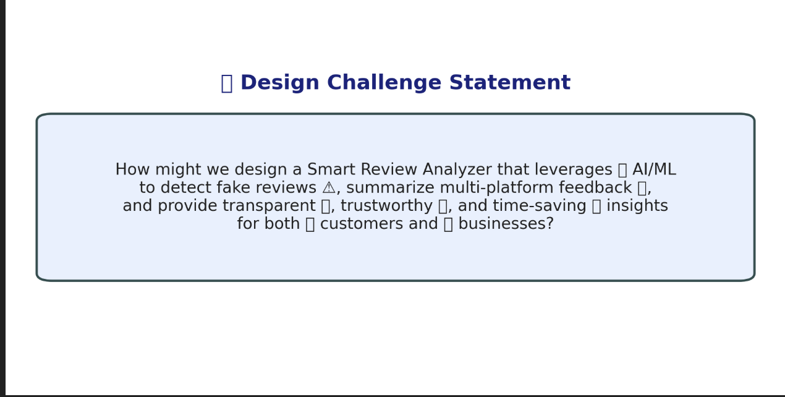

It’s short, human centered, and directly connects to your project goal. 17. Validating the Problem Statement with Stakeholders for Alignment
Validation Plan:
The objective of the validation plan is to ensure that the Smart Review Analyzer is accurate, trustworthy, user-friendly, and adaptable to different review formats and languages across platforms.
The system must achieve at least 90% precision in filtering fake/biased reviews, while providing clear summaries and transparent explanations so users and businesses can make informed decisions.
Stakeholder/User | Role | Feedback on Problem Statement | Suggestions for Improvement
Students | End Users | The tool is simple and helps me quickly decide which reviews I can trust. | Add an explanation of why a review is flagged as fake/biased.
Teachers | End Users | Students are learning to evaluate reviews critically instead of blindly trusting star ratings. | Provide additional resources (guides, lessons) on digital literacy alongside the tool.
Researchers | End Users | The sentiment analysis and AI-driven summarization are impressive. | Ensure multilingual and cross-platform consistency is improved in future versions.
Business Owners/Managers | End Users | Helps me understand customer concerns faster and improves service response. | Add visual dashboards with trends for quicker decision-making.
Technology Developers | Developers | The system design is optimized for real-time feedback processing. | Enhance API access for integration with e-commerce sites and social media.

18. Ideation
Ideation Process
Idea Number | Proposed Solution | Key Features/Benefits | Challenges/Concerns
Idea 1 | AI-Powered Fake/Spam Review Detection | Identifies fake or spam reviews with high accuracy | Ensuring dataset quality and minimizing false positives
Idea 2 | Review Summarization Engine | Provides concise summaries of lengthy reviews | Preserving key details while reducing redundancy
Idea 3 | Sentiment Analysis with Credibility Scores | Assigns sentiment and trust levels to reviews | Avoiding biases and ensuring transparency
Idea 4 | Multi-Platform Integration (Browser Extension / API) | Analyzes reviews across Amazon, Flipkart, Google, etc. | Maintaining compatibility and ensuring data privacy
Idea 5 | Smart Categorization | Groups reviews into themes (price, quality, service, delivery) | Correctly handling mixed-language and slang reviews

Solution Concept Form – Smart Review Analyzer
- Problem Statement:
Traditional review-checking methods are slow, scattered across platforms, and vulnerable to fake/spam reviews. This creates confusion for customers and makes it hard for businesses to extract meaningful insights from feedback.
- Target Audience:
General online shoppers, students, businesses, researchers, educators, and e-commerce platforms that want to analyze and act on multi-platform user feedback effectively.
- Solution Overview:
The AI-Powered Smart Review Analyzer uses natural language processing, machine learning, and real-time cross-platform data aggregation to detect fake reviews, summarize large volumes of feedback, and provide actionable insights while ensuring fairness and transparency.
- Key Features:
Feature | Description
Fake Review Detection | Identifies fake/biased/spam reviews across multiple platforms.
Summarization & Insights | Generates quick, easy-to-read summaries of long reviews.
Sentiment Analysis | Classifies reviews into positive, negative, or neutral tones.
Cross-Platform Integration | Works seamlessly with e-commerce sites, review portals, and apps.
Transparency & Explanations | Explains why a review is flagged or scored in a certain way.
- Benefits:
Benefit | Description
Trustworthy Decisions | Provides users with verified, credible review insights.
Time Efficiency | Saves time by summarizing reviews across platforms.
Business Growth | Helps businesses quickly identify problem areas and improve services.
Digital Literacy | Encourages critical thinking by showing review authenticity explanations.
6.Our AI-driven Smart Review Analyzer not only detects fake/biased reviews but also summarizes multi-platform feedback into clear, transparent insights — empowering both customers and businesses to make confident, data-driven decisions.
- Key Metrics:
  - Precision & recall in detecting fake reviews
  - False positive/negative rates
  - Average summarization time
  - User trust/satisfaction scores
  - Daily active users & engagement
  - Integration success with platforms
- Feasibility Assessment:
By using NLP models, real-time APIs, and scalable cloud solutions, the system is technically feasible. It can adapt to different languages, review styles (emojis, slang), and new patterns of spam reviews while ensuring privacy and platform compatibility.
- Next Steps:
  - Research & Planning: Study fake/spam review trends and user pain points.
  - System Design: Create intuitive UI/UX with dashboards and transparency features.
  - Development: Implement detection, summarization, and sentiment modules.
  - Testing & Feedback: Pilot test with students, customers, and business managers.
  - Launch: Deploy with initial platforms (Amazon, Flipkart, Google Reviews).
  - Iterate & Scale: Add multilingual support, improve detection, and expand integrations.

